
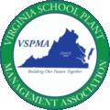
Virginia School Plant Management Association
2026 Scholarship Application

Region #:

See Attached List for Region #

This form is to be used by applicants to post-secondary institutions and current post-secondary students not employed by a school district.

Scholarship Program Procedure for Submitting Application
- The information shall be completed in Section I by all applicants
- High School Seniors and High School Counselors shall complete Section IIa and IIb
- Include with the application the following information:
Three letters of recommendation to include one from a member of Facilities, Maintenance, Custodial Staff, or Instructional staff member in a trade-related field
  - Transcript to include grades and attendance
  - A brief statement that describes why you want to be a recipient of the VSPMA Scholarship; the course of study and major you plan to follow; your proposed occupation or profession; and what you want to accomplish upon completion of your studies
  - One-page essay of 250 words or less which describes how your chosen field of study relates to preserving the learning environment in schools through maintenance, construction, or custodial support, technology, and analysis..
- Scholarship Application documents must be submitted electronically no later May 31, 2026 to Dawson_Rae@ccpsnet.net
- Judging of the applications will be by a committee composed of VSPMA Board Members. The criteria for judging applicants will include, but not be limited to, ACT and/or SAT scores; GED scores; GPA; curriculum; attendance; honors; extracurricular and work activities; and essay.
- To be completed by all applicants: (Answer all questions fully and use additional paper as needed. Please provide a permanent address and phone number for contact if needed.)

 | Name: |  |  | Phone: ( )
 | Email Address:
 | Street Address or P.O. Box:
 | City: | , VA |  | Zip Code:
 | Additional Point of Contact:
 | Email: |  | Phone: ( | )

Please choose one of the following options.

- I would like to be considered for a financial scholarship that would be used for tuition at an institution of continuing education.
- I would like to be considered for a financial scholarship that would be used to purchase the tools or equipment needed to pursue a degree or certificate.
Please briefly describe the types of tools or equipment you would purchase:
__________________________________________________________________________________________________________________

IIa. (If student is undecided at time of application intended Post-Secondary and Registrar Address May be left blank.)

Intended Post-Secondary School and Major:

Address and P.O. Box for Registrar/Business Office:

Diploma or GED Received from:

Extracurricular Activities (e.g. Sports, Leadership, Organizations/Clubs – show years of involvement, offices held, etc.):

Honors, Awards, and Recognition:

Community Involvement and Other Activities:

Work Experience:

Page |
IIb. To be completed by High School Counselor or Principal: (Principal or Counselor – The VSPMA Membership thank you for your assistance. Please complete this section and provide the applicant’s record of high school academic performance as indicated below.)

Academic Information: ACT: SAT:

Cumulative High School GPA: GED: Days Absent: Senior Year:
0-5 | 6-10 | 10+

Junior Year:
0-5 | 6-10 | 10+

Note any honors classes or outstanding achievements for the applicant:

Describe any special and/or deserving qualities the applicant possesses:

School Official’s Signature: Date:

School Official’s Name:

High School (Name//District):

Address:

Phone:

Applicant’s Signature: Date:

Copy High school transcript must be received by May 31, 2026 electronically to
Email: Dawson_Rae@ccpsnet.net
Mailing address (if needed)
Attn: Dawson Rae, VSPMA Scholarship Committee
9800 Krause Road, Chesterfield, VA 23832

All Applicants

Three (3) Letters of Recommendation must be received no later than May 31, 2026.

- Letters may be included as part of the application packet or mailed/emailed separately
- One recommendation must be from a member of Facilities, Maintenance, Custodial Staff, or Instructional staff member in a trade related field.
- If the applicant is a post secondary student who is a Virginia resident attending school out of state the recommendation may come from staff at the post secondary institution he or she is attending.

Letters may submitted electronically with the subject line including VSPMA Scholarship Application via email
Email: Dawson_Rae@ccpsnet.net

Page | 5

All Applicants
III. In a brief statement describe why you want to be a recipient of the VSPMA Scholarship; the course of study and major you plan to follow; your proposed occupation or profession; and what you want to accomplish upon completion of your studies

Page | 6

All Applicants
ESSAY: In the space provided below (or submit as an attachment), please elaborate on the following essay topic in 250 words or less:

How your chosen field of study relates to preserving the learning environment in schools through maintenance, construction, or custodial support.

Verification of Enrollment
(Current Post Secondary Students Only)

Dear Admissions/Registrar:

This student is applying for a scholarship from the Virginia School Plant Managers Association (VSPMA). Please complete the information requested below for verification of the student’s acceptance to this academic institution.

In addition, please verify the student’s current enrollment status and total number of hours completed. This information should be included in the student’s scholarship application package. Thank you.

To be completed by the student:

I authorize the above requested information to be released to the VSPMA with my application for a scholarship.

Student/Applicant Date

Academic Institution

To be completed by Admissions/Registrar:

Student/Applicant Academic Institution

Date of Acceptance of this Institution:

Is this student currently enrolled?

Is this student full time or part time?

VSPMA REGION LIST

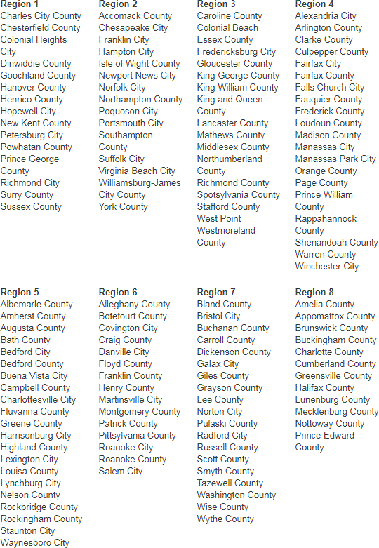

Page | 9

